Day-13 (26/6/2025)
Emp ID : 110714877
NAME :Kinnera venkatamma

Task 001

import java.util.LinkedList;

public class Task001_DS_LinkedList {
public static void main(String[] args) {
LinkedList<String> fruits = new LinkedList<>();

fruits.add("Apple");
fruits.add("Banana");
fruits.addFirst("Orange");
fruits.addLast("Grapes");

System.out.println("First Element: " + fruits.getFirst());
System.out.println("Last Element: " + fruits.getLast());

fruits.removeFirst();
fruits.removeLast();

for (String fruit : fruits) {
System.out.println(fruit);
}
}
}
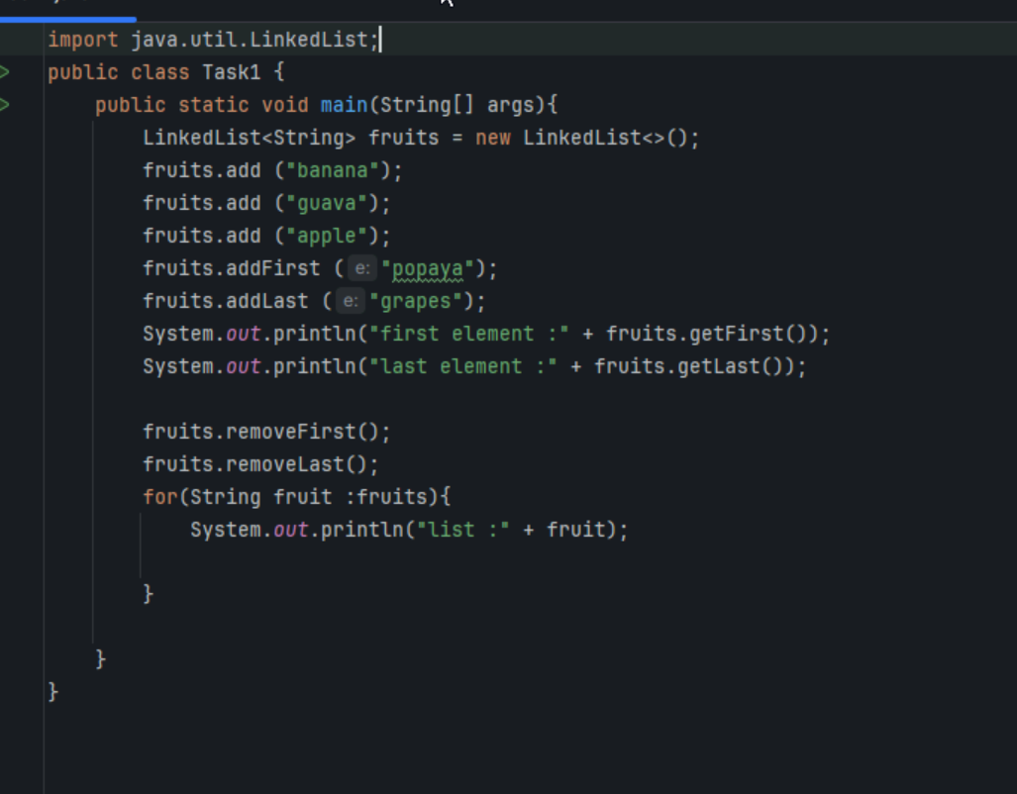
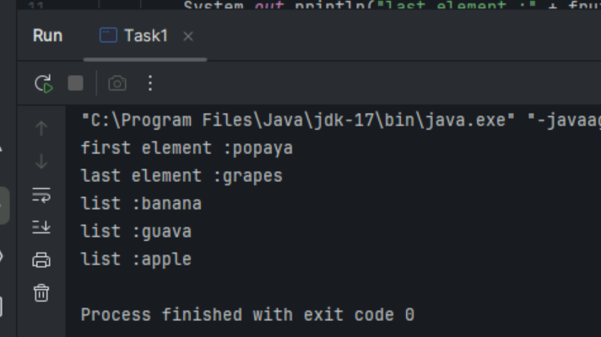
class Node<T> {
T data;
Node<T> next;

public Node(T data) {
this.data = data;
this.next = null;
}
}
public class CustomLinkedList<T> {
private Node<T> head;
private int size = 0;

public void add(T data) {
Node<T> newNode = new Node<>(data);
if (head == null) {
head = newNode;
} else {
Node<T> current = head;
while (current.next != null) {
current = current.next;
}
current.next = newNode;
}
size++;
}

public void addFirst(T data) {
Node<T> newNode = new Node<>(data);
newNode.next = head;
head = newNode;
size++;
}

public T removeFirst() {
if (head == null) {
throw new NoSuchElementException("List is empty");
}
T removedData = head.data;
head = head.next;
size--;
return removedData;
}

public T get(int index) {
checkBounds(index);
Node<T> current = head;
for (int i = 0; i < index; i++) {
current = current.next;
}
return current.data;
}

public int size() {
return size;
}

private void checkBounds(int index) {
if (index < 0 || index >= size) {
throw new IndexOutOfBoundsException("Index out of bounds");
}
}
}
public class Task002_DS_CustomLinkedList {
public static void main(String[] args) {
CustomLinkedList<String> liobj = new CustomLinkedList<>();
liobj.add("Anitha");
liobj.add("Verma");
liobj.addFirst("Jack");

System.out.println("First Element: " + liobj.get(0));
System.out.println("Size: " + liobj.size());

liobj .removeFirst();

System.out.println("First Element after removal: " + liobj.get(0));
System.out.println("Size after removal: " + liobj.size());
}
}

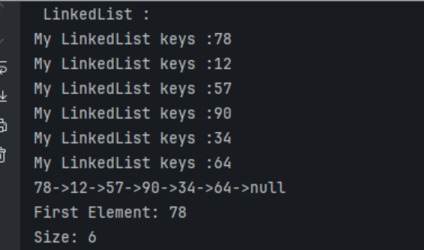
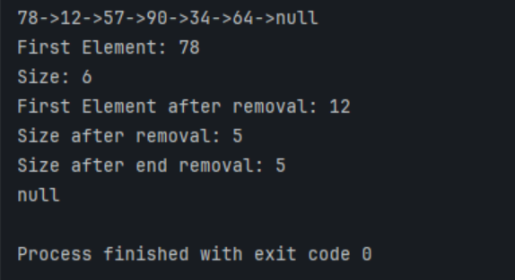

Task 3 List down the methods of linked lists..

Add – first/inbetween/last
Traverse
Sorting/searching
Remove-first/last
Size()
Get()

Task 4: What are the operations of data structures.. I liner

Traversing
Insertion
Deletion
Searching
Sorting

Task 5: Wap to create a linked list add 5 elements to it and replace 3 rd element with different value..

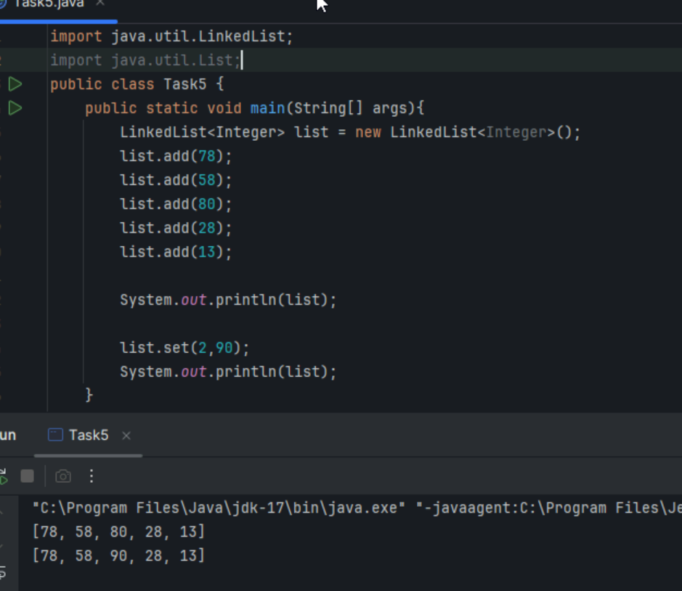

Task 6: Wap to create a linked list to add 5 elements and remove any element and display
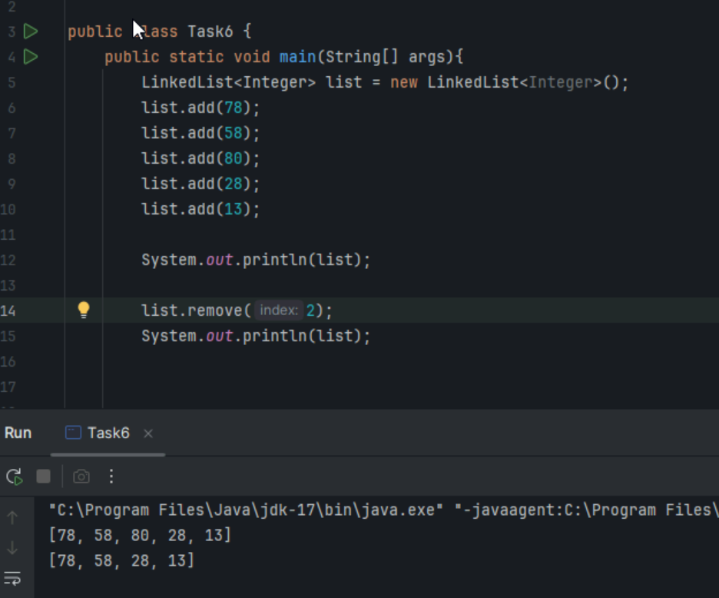

Task 7: Wap to create a linked list to add 5 elements and display the list using for (use get() ) and for each loops

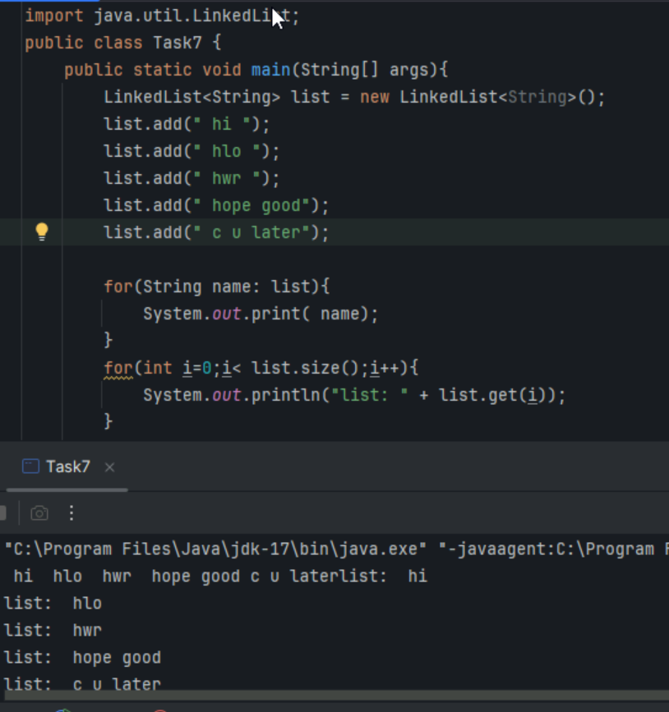

Task 8: Createa a linked list and few items and convert it into an array
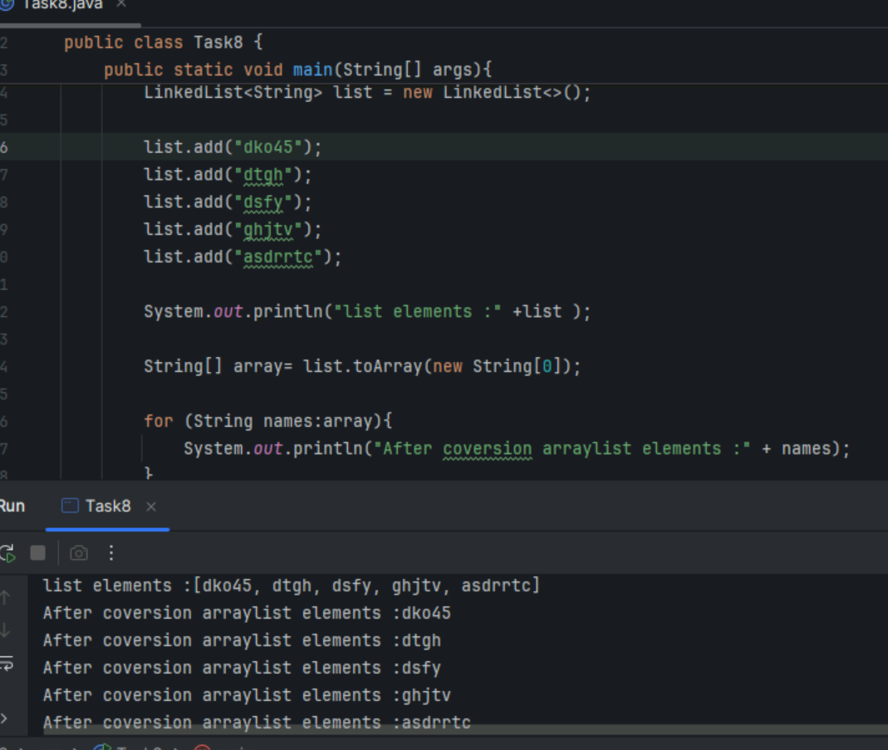

Task 9: Createa alinked list add few items and clone the 1st linked list with the 2nd linked list

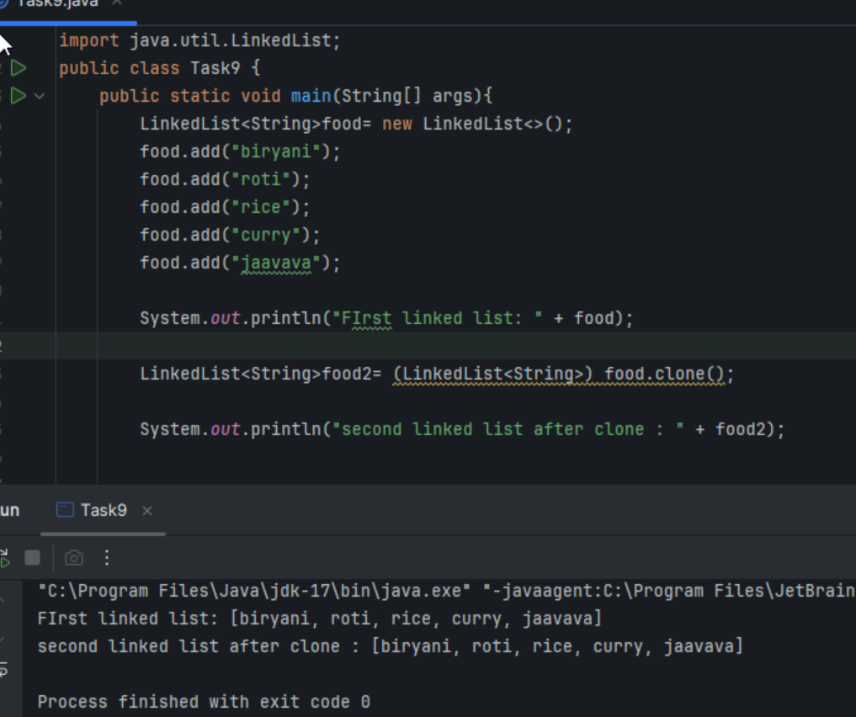

Task 10: Create linked list and iterate the values using ListIterator class in util package

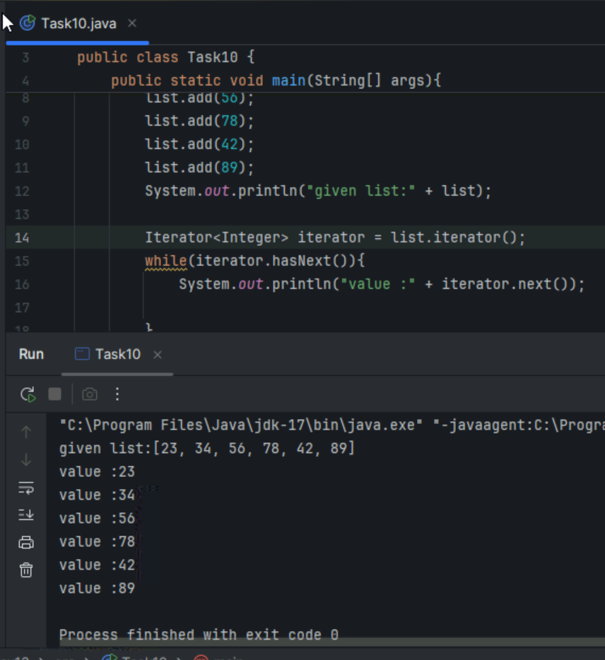

Task 11:Create a linked list and use push and pop methods.

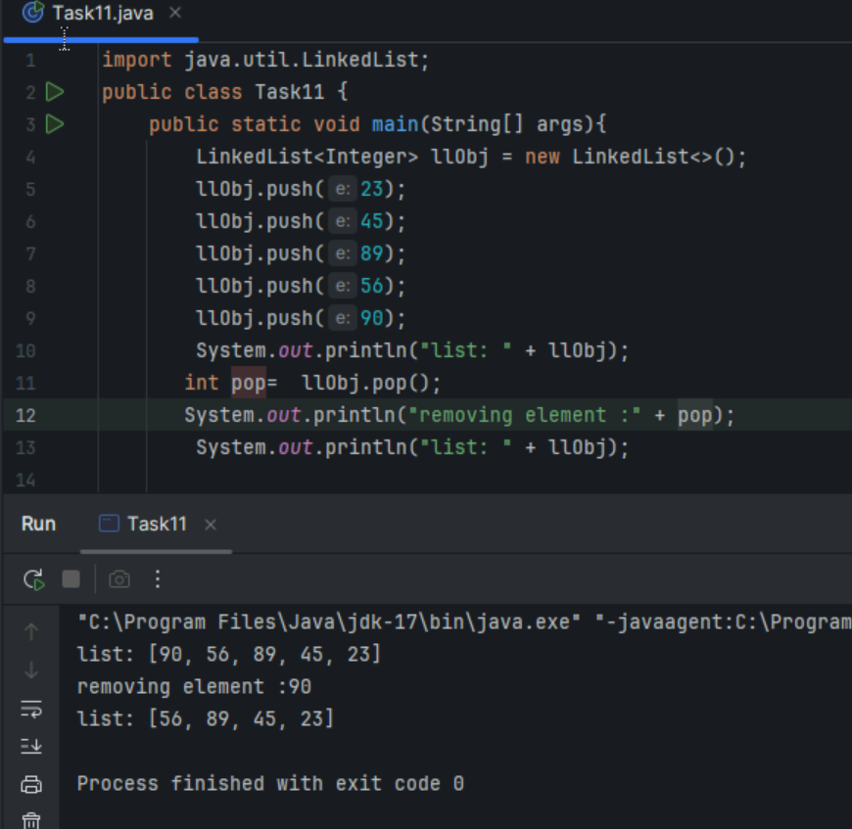
Task 12: Difference between Iterator and split Iterator

Feature | Iterator | Spliterator
Primary Use | Sequential traversal of collections. | Parallel traversal and processing of data, especially with Streams.
Splitting | Does not support splitting. | Supports splitting its elements into sub-Spliterators for parallel  processing.
Iteration | External iteration (client controls the loop). | Internal iteration (framework controls the loop, e.g.,\  forEachRemaining()).
Methods | hasNext(), next(), remove(). | tryAdvance(), forEachRemaining(), trySplit(),  estimateSize(), getExactSizeIfKnown(),  characteristics().
Parallelism | Not designed for parallel processing. | Designed to facilitate parallel processing and leverage multi-core architectures.
Size Knowledge | Does not provide information about the size of the remaining elements. | Can provide an estimate or exact size of the remaining elements.
Characteristics | No explicit characteristics. | Provides characteristics like ORDERED, DISTINCT, SORTED, SIZED, etc.
Introduction | Introduced in JDK 1.2. | Introduced in JDK 1.8 as part of the Streams API.

Task 13: Below is the code for Split iterator… run it to see the output..

Can you it to sout()... and see ..
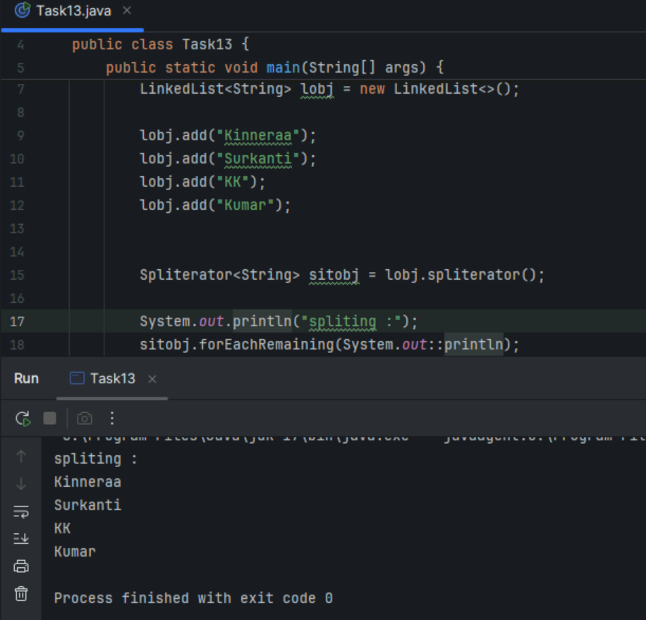
Task 14:

Create a linked list and display items into 2 lists using split iterator

Hint:

Spliterator<String> itobj2 = itobj1.trySplit();

while( itobj1.tryAdvance( (n) -> { System.out.println(n); } ) );
16.53 to 16.57

import java.util.LinkedList;
import java.util.Spliterator;

public class Task0014_DS_Linkedlist_SplitItr2Lists {
public static void main(String[] args) {

LinkedList<String> llobj = new LinkedList<String>();
llobj.add("Prasunamba");
llobj.add("Meher");
llobj.add(".MK");
llobj.add("MP");

Spliterator<String> itobj1 = llobj.spliterator();
Spliterator<String> itobj2 = itobj1.trySplit();

System.out.println("spliterator 1");
while( itobj1.tryAdvance( (n) -> { System.out.println(n); } ) );

System.out.println("spliterator 2");
while( itobj2.tryAdvance( (n) -> { System.out.println(n); } ) );
}
}
code not worked …

Task 15: What do you understand by a pointer?

In programming, a pointer is a variable that stores the memory address of another variable. Instead of holding the value of a variable directly, it holds the location in memory where that value is stored. This allows for efficient memory management and manipulation of data.

Task 16: Difference between * and & in pointers?

In the context of pointers in C and C++, the * (asterisk) and & (ampersand) symbols serve distinct and often inverse functions:
& (Address-of Operator):
This is a unary operator used to obtain the memory address of a variable.
When placed before a variable name (e.g., &myVariable), it returns a pointer to that variable's memory location.
Example: If int x = 10;, then &x would yield the memory address where the value 10 is stored.
* (Dereference Operator / Pointer Declaration):
Pointer Declaration: When used in a variable declaration (e.g., int *ptr;), it declares a variable as a pointer to a specific data type (in this case, an integer). This ptr variable will store a memory address.
Dereferencing: When used as a unary operator on an already declared pointer variable (e.g., *ptr), it "dereferences" the pointer, meaning it accesses the value stored at the memory address the pointer holds.
Example: If int *p = &x; (where x is an integer variable), then *p would access the value of x (which is 10 in the previous example).
In essence:
& tells you where a variable is located in memory.
* (when dereferencing) tells you what value is stored at the memory location a pointer is pointing to.
These two operators are fundamentally linked, as * is used to access the data that & points to.

Task 17: Wap in c or c++ to implement the use of pointers.

#include <stdio.h>

int main() {
int var = 10;

// Store address of var variable
int* ptr = &var;

// Directly accessing ptr
printf("%d", ptr);

return 0;
}

Task 18:Wap to create a doubly linked list

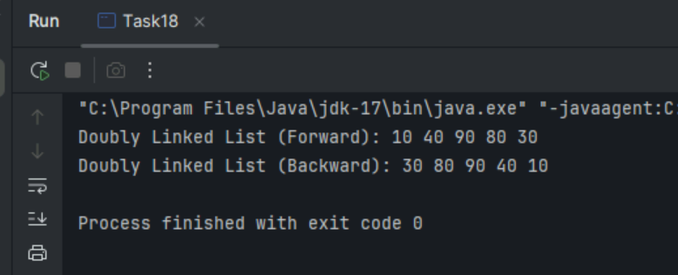

Home Tasks:

- List Advantages and disadvantages of linked List

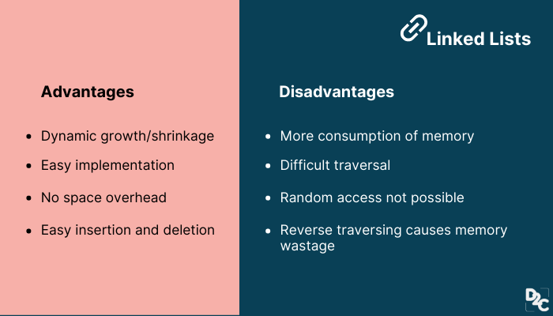
- Applications of Linked list



